**DATA BASE ASSESMENT…..**

CREATE TABLE product

( Product_ID INT PRIMARY KEY AUTO_INCREMENT,

Product_Name VARCHAR (20),

Product_Price DECIMAL (6,2)

Product_Code INT );

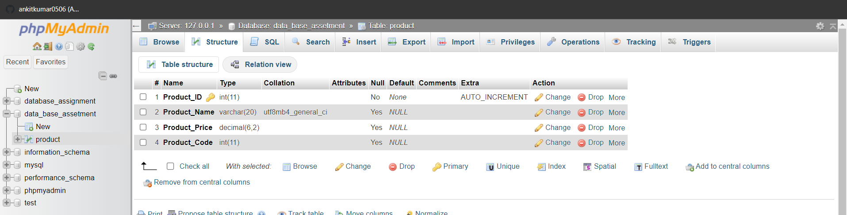

1)INSERT INTO product (ProductName, Product_Price, Product_Code) VALUES ('Mother Board', '3200.00', '15'),('Key Board', '450.00', '16'), ('ZIP Drive', '250.00', '14'), ('Speaker', '550.00', '16'), ('Monitor', '5000.00', '11'), ('DVD Drive', '900.00', '12'), ('CD Drive', '800.00', '12'), ('Printer', '2600.00', '13'), ('Refill Cartridge', '350.00', '13'), ('Mouse', '250.00', '12');

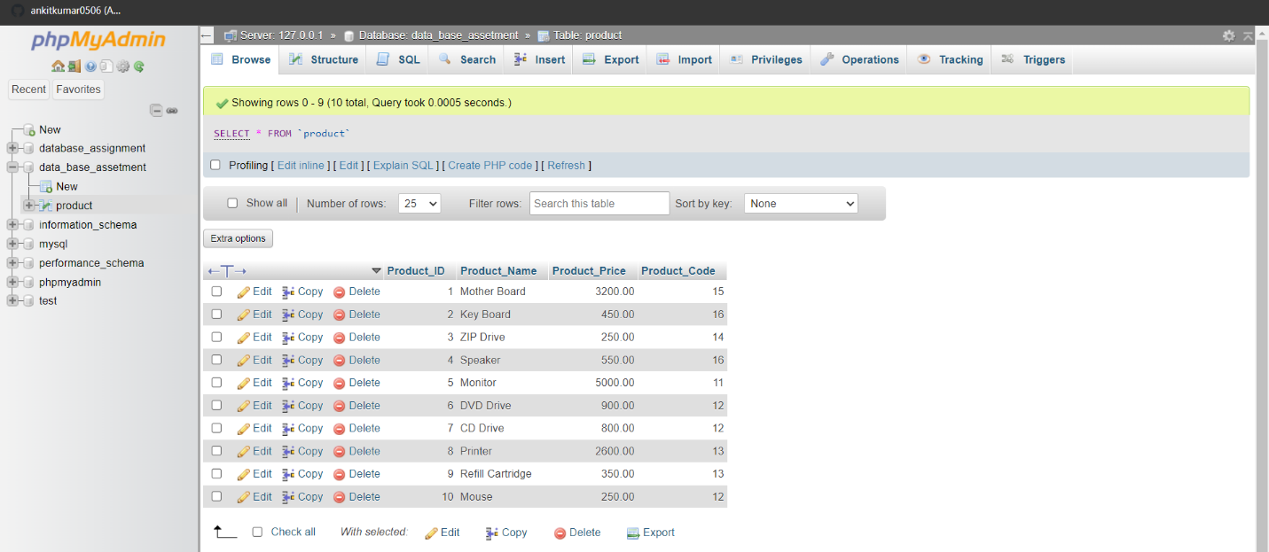

2)SELECT * FROM product WHERE Product_Price >=250;

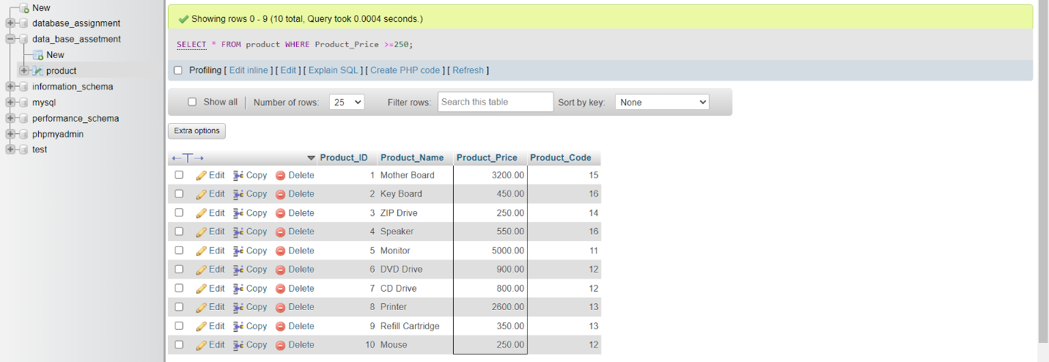

4)SELECT Product_Name, Product_Price

FROM product

WHERE Product_Price >= 250.00

ORDER BY Product_Price DESC;

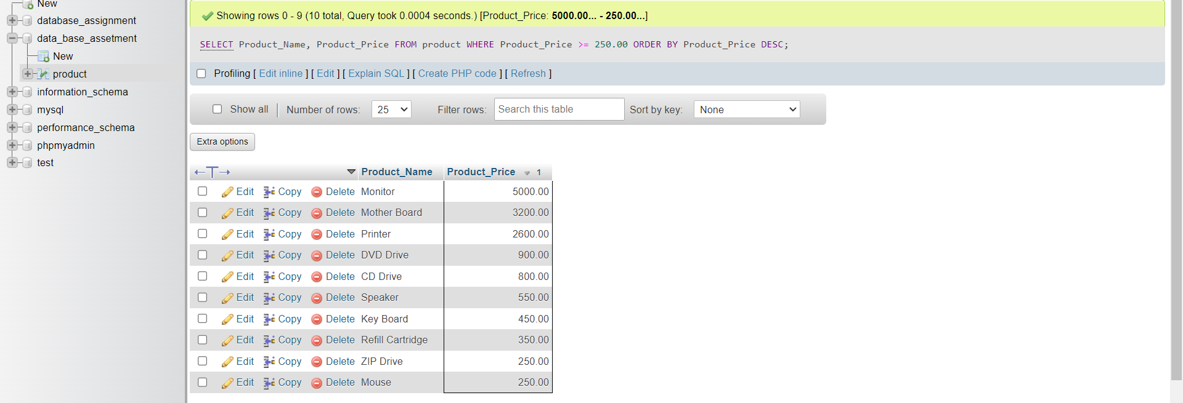

5)SELECT Product_Name, Product_Price

FROM product

ORDER BY Product_Price ASC

LIMIT 1;

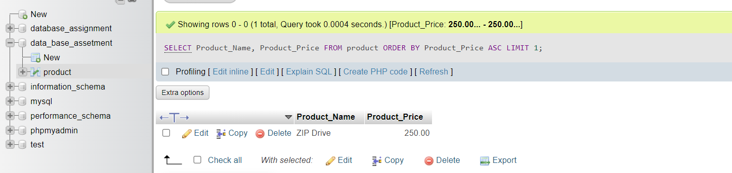

6)SELECT AVG(Product_Price) FROM product;

